Project Design Phase-I Problem

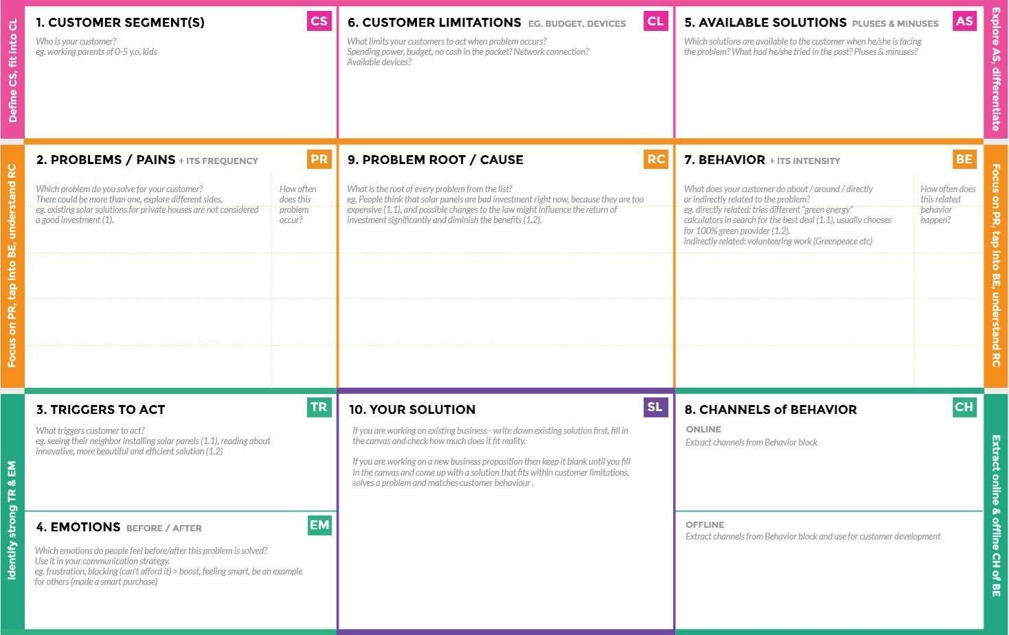

**BEFORE**: Customer can’t get the exact

damage value insurance.

**AFTER**: Customer easily get the exact value for insurance within 24 hours

**OFFLINE**: The customer should obey the rules correctly

**ONLINE:** The customer Data send through application and Insurance data will send to the server to bank.

* “AI based intelligent vehicle damage assessment and Cost Estimator for Insurance Companies”
* It helps vehicle owner to get correct estimated value for vehicle damage.

People should obey the traffic rules to avoid accident in national level so it reduces accident

Don’t drive a vehicle during a phone call. Don’t drunk and drive. Obey the traffic rules. Use headlight during night time. Use seatbelt.

It requires an or continuous internet connections to be successful. Server did not work properly all the time.

* The customer face wrong value for vehicle damage. In this app correct estimated value is given or shown.
* That can be ratify the problem in our application

We have 24/7 customer support to solve customer problems to get easier application to fill.

* Not good about Insurance knowledge.
* Lack of proper Documentation.

Vehicle owner and Insurance companies.

Solution Fit

|  |  |
| --- | --- |
|  |  |
| **Team ID** | **PNT2022TMID12053** |
| **Project Name** | Intelligent Vehicle Damage Assessment and Cost Estimator for Insurance Companies |